mBot Adventures:

Demo Instructions

To install the program to use the mBot mega you must go to the website:

<https://mblock.cc/pages/downloads>

Next, you will scroll down to where it says download mBlock.  
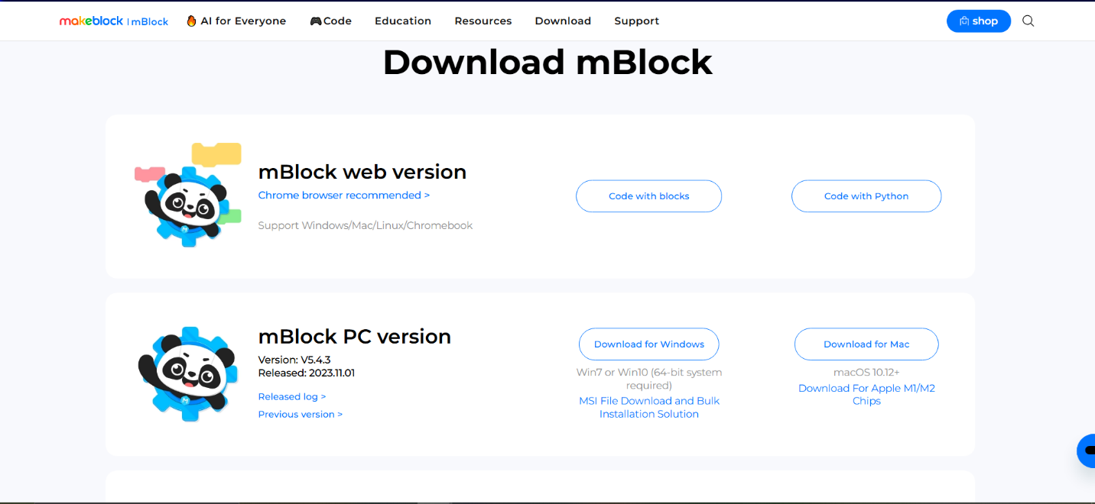  
Look at where it says PC version, and download the one that corresponds to the device being used (Either Windows or Mac)

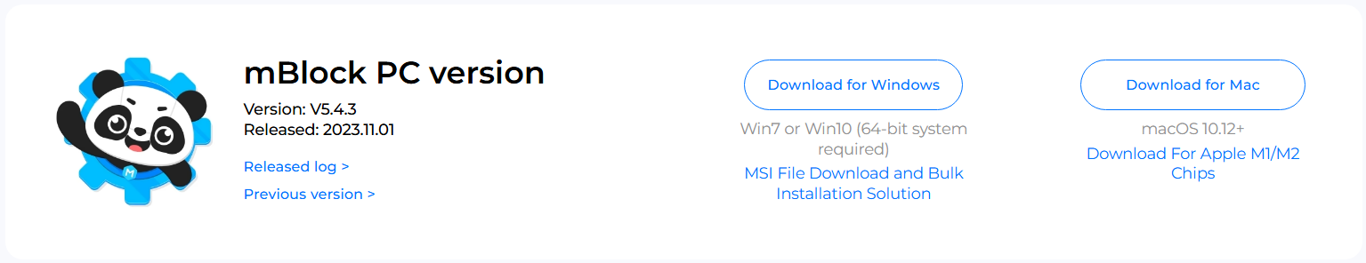

After downloading, your IDE should look like this when opened (yours may be white instead of black when first opened):

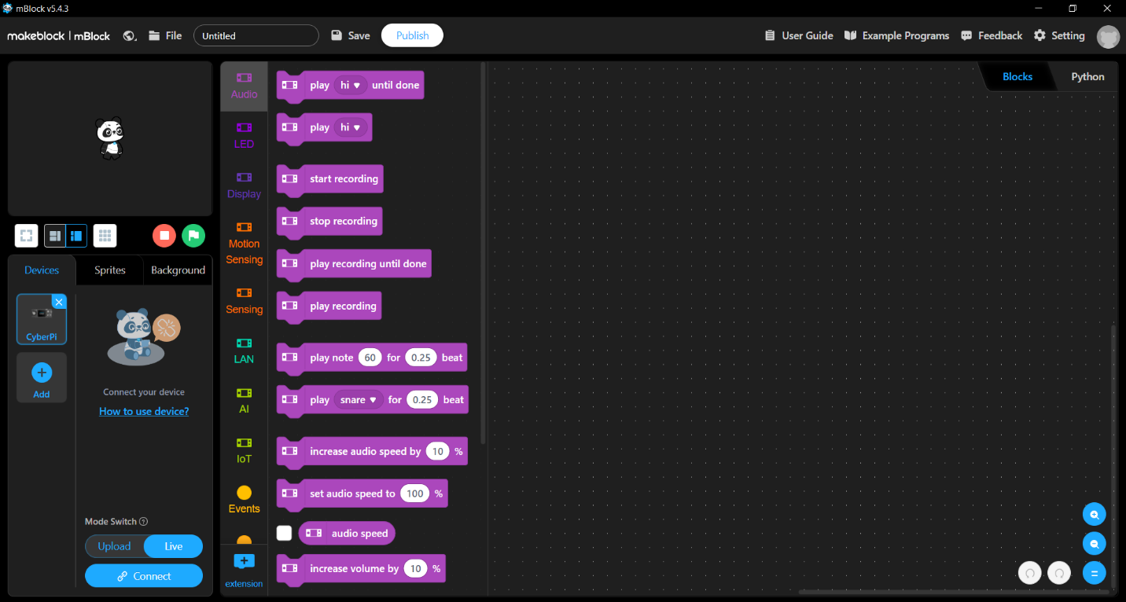

To add the mBot mega click the add button on the left side of the screen

Next, click the mBot mega to add it to your devices, and click OK after clicking mBot mega

Make sure that the mode is switched to upload and not live, the blue should be highlighted for Upload

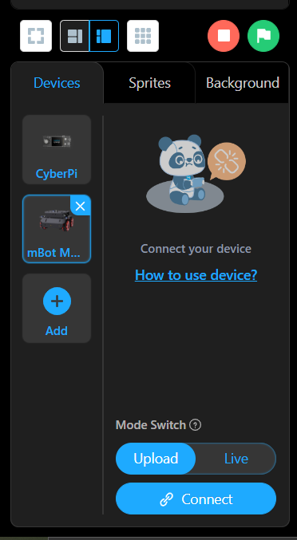

Once your mBot is connected like this,

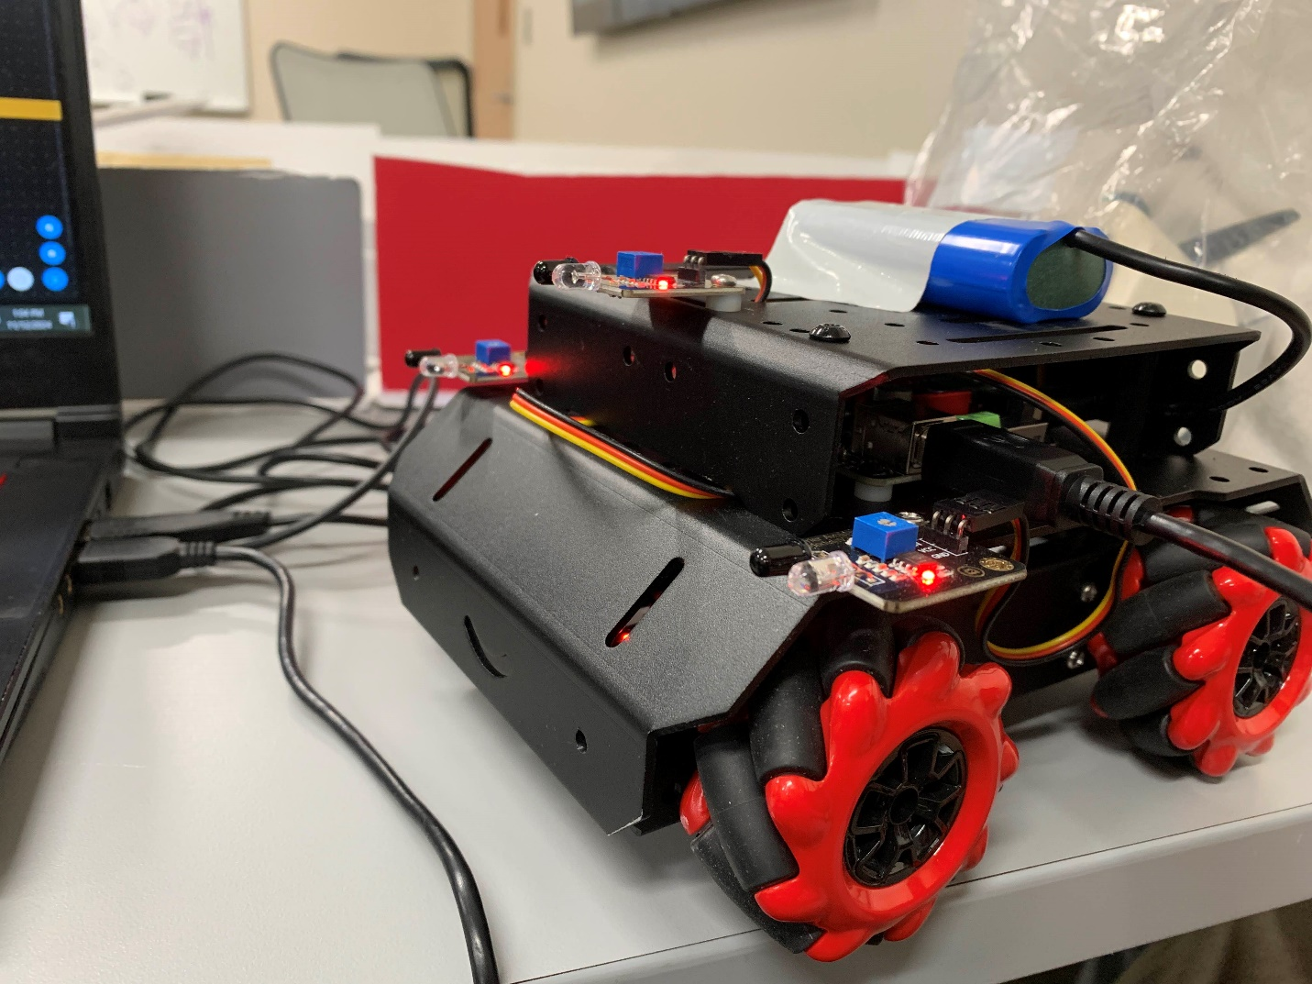

Make sure the wire is connected to the raspberry pi on the bot and the USB is connected to your device, click the connect button and connect your bot.

We have three parts to our demo:

1. Coding the bot to move back and forth
2. Coding the bot to detect an obstacle
3. The crash detection feature
4. Coding the bot to move back and forth

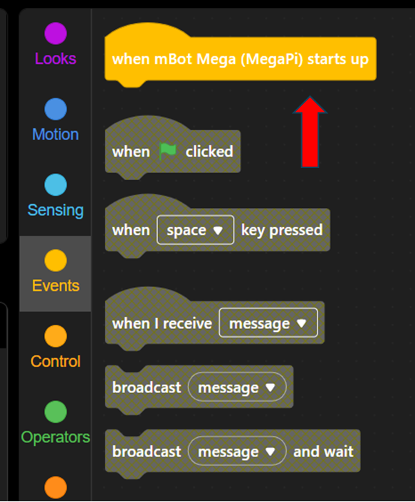

Make sure to grab two of the move blocks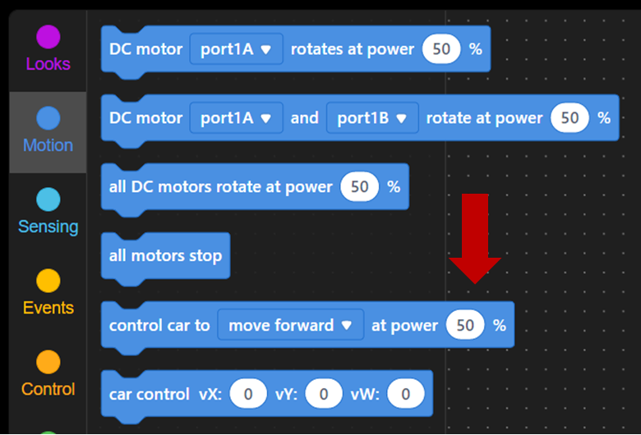

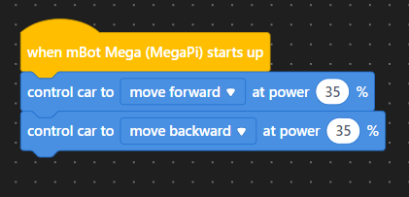

Make sure to grab two wait second blocks

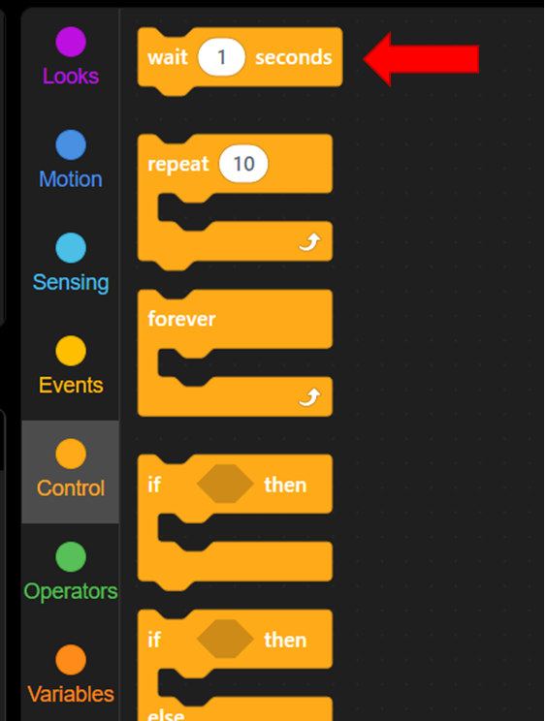

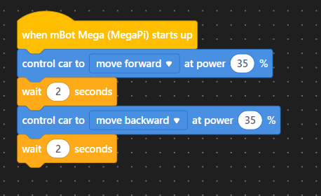

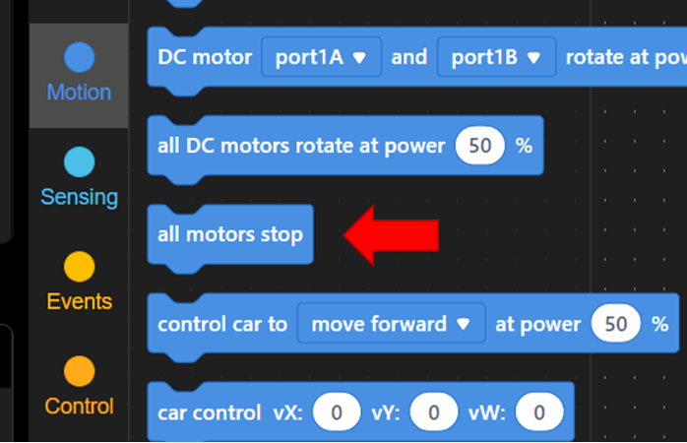

1. Coding the bot to detect an obstacle



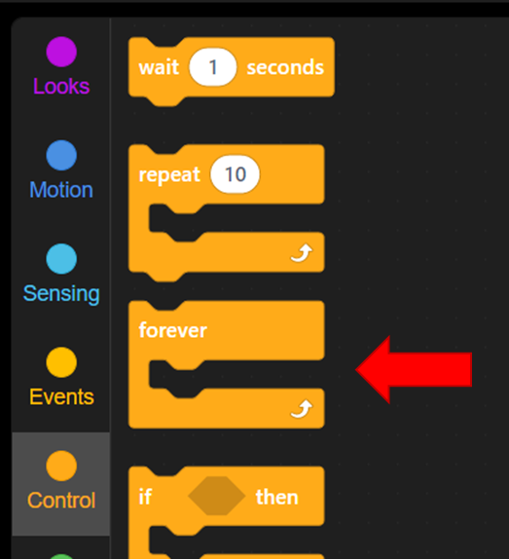

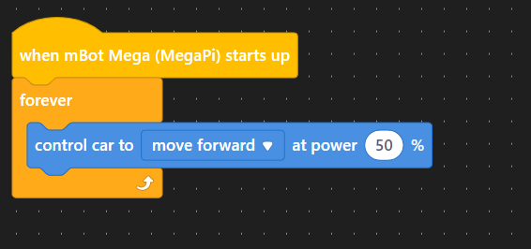

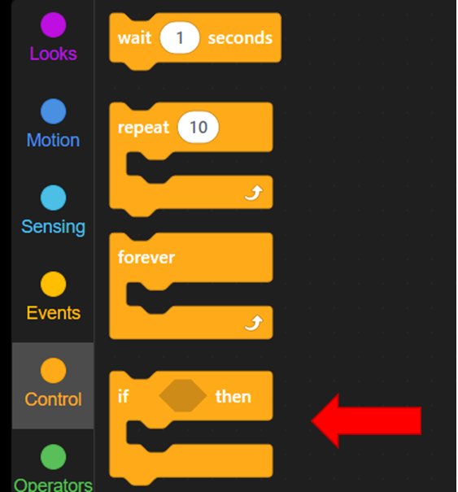

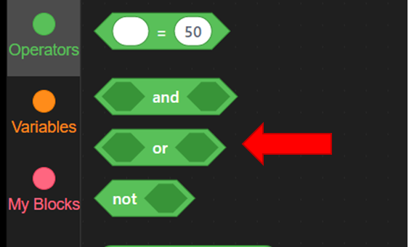

Grab two of the sensors block, and set them both to pin A6 and pin A8

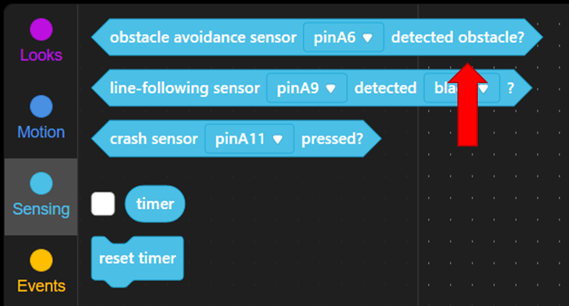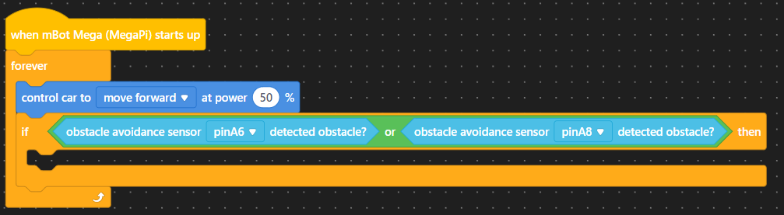

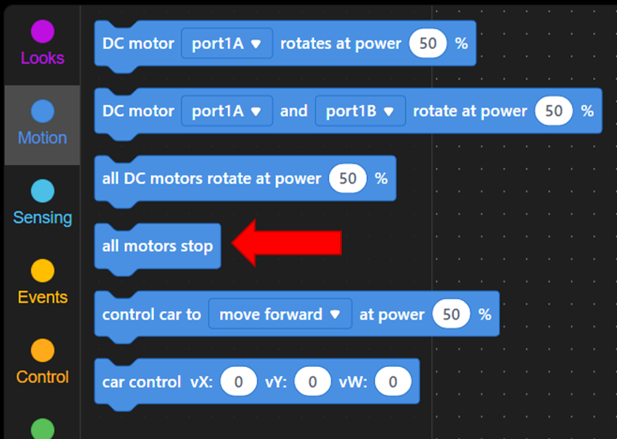



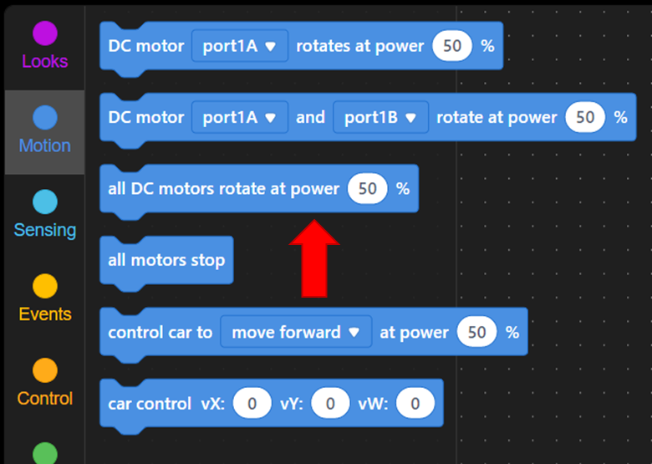



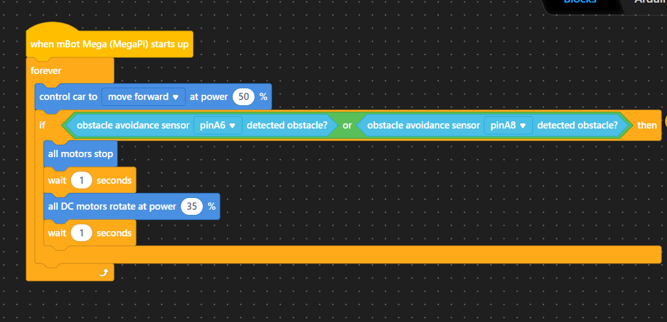

1. The Crash Detection Code





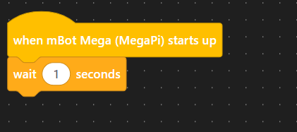





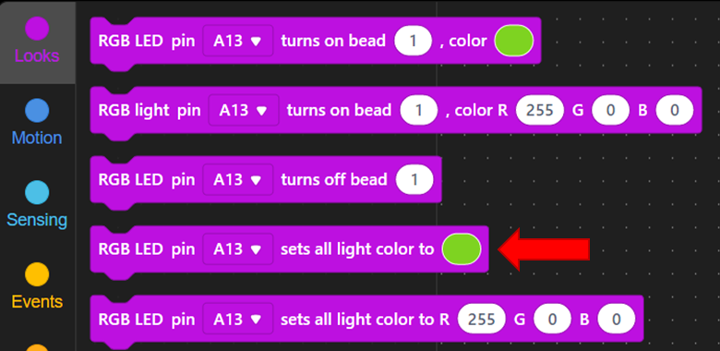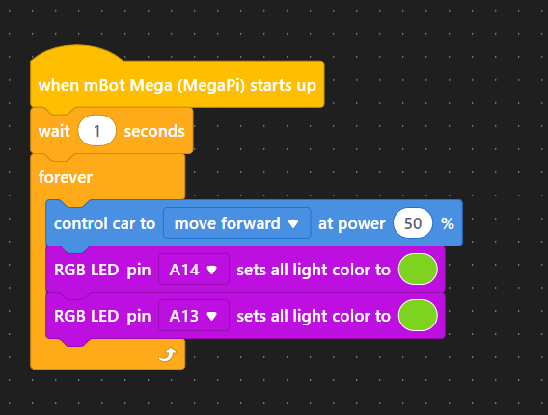



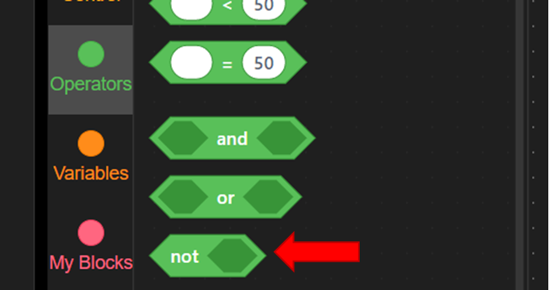



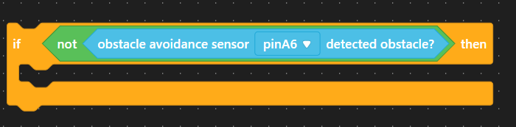

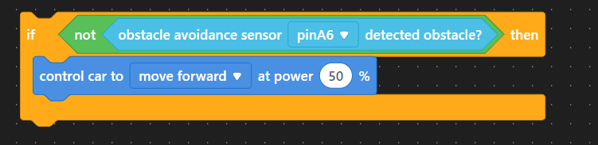



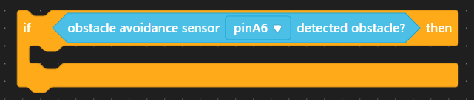

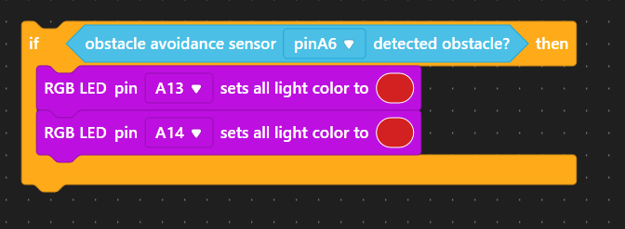





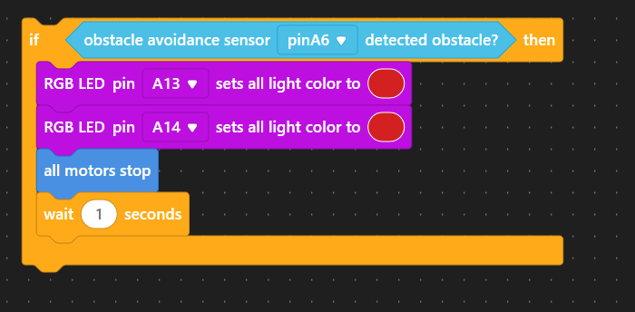





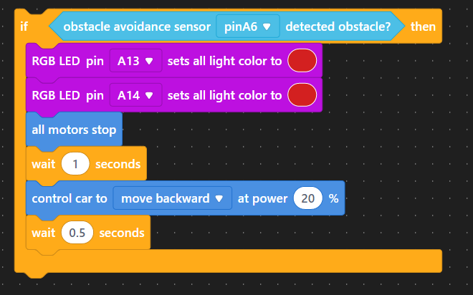

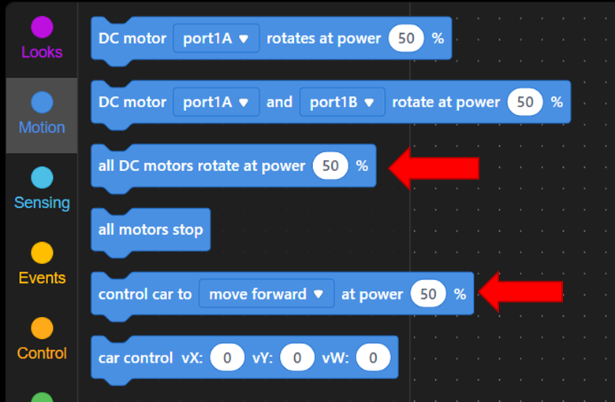



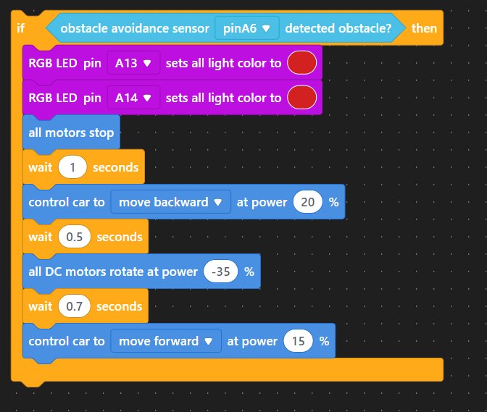

Duplicate both the if statements and change it to pinA8 by clicking right click and place it under the previously created if statements

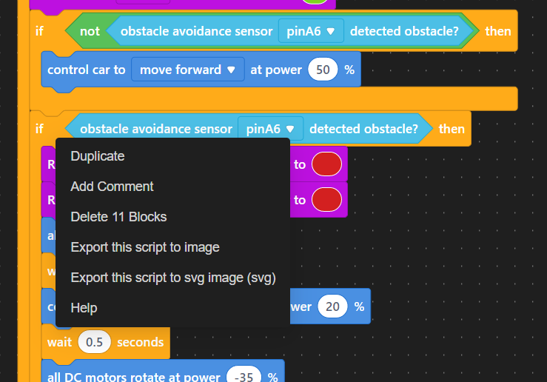



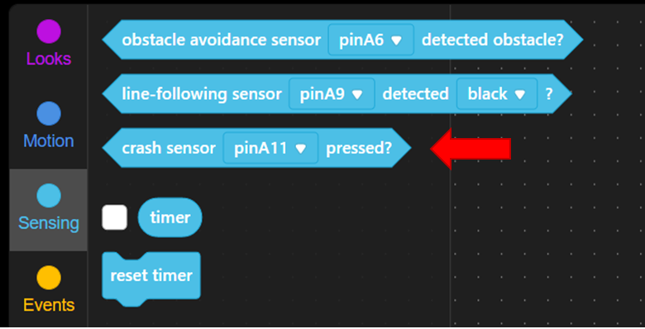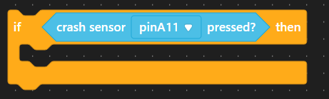

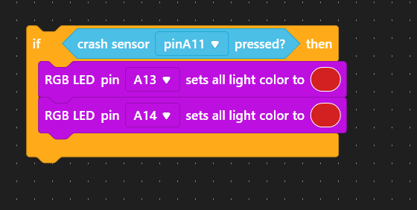

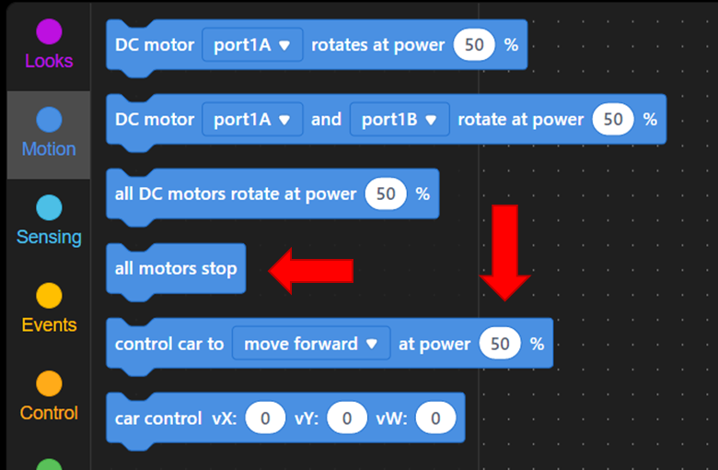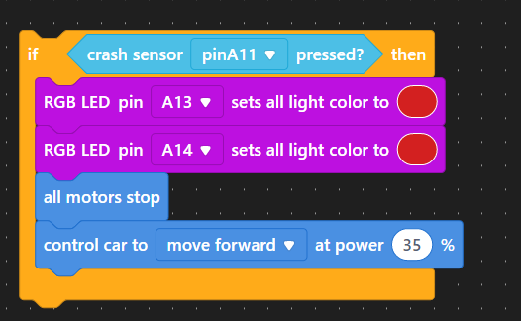



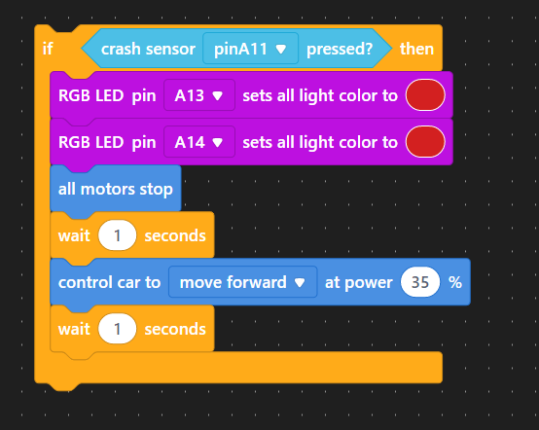

Duplicate it again by clicking right click. Set it for pinA12

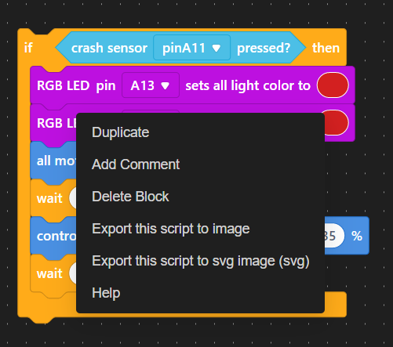

Duplicate the two first if statements we created by clicking right click and dragging them to the bottom

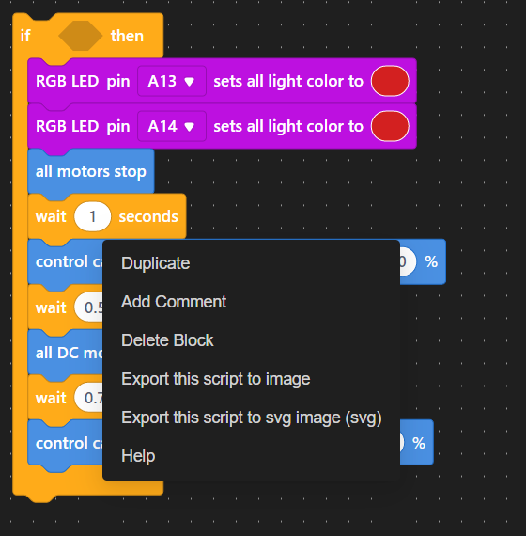

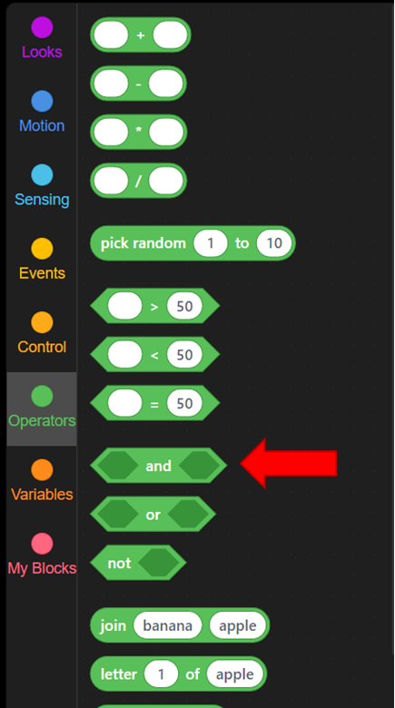



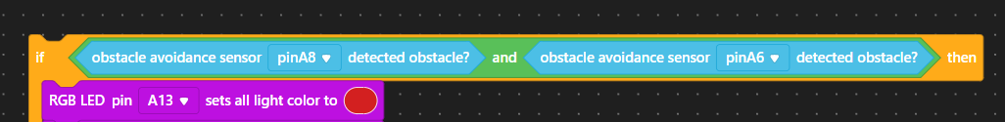

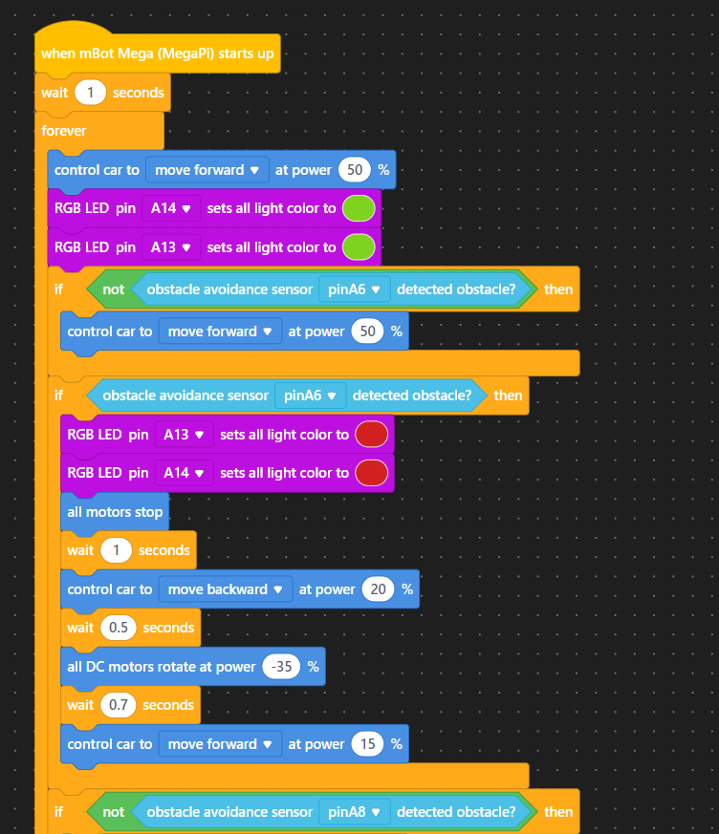

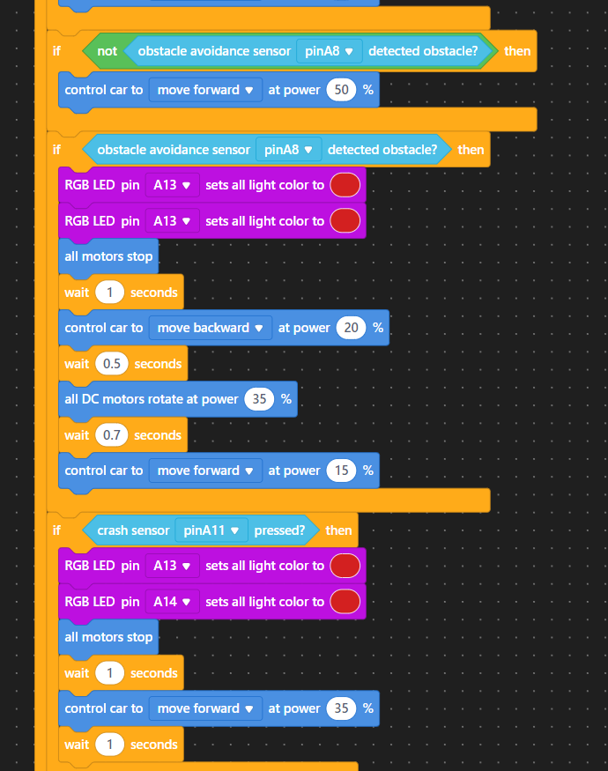

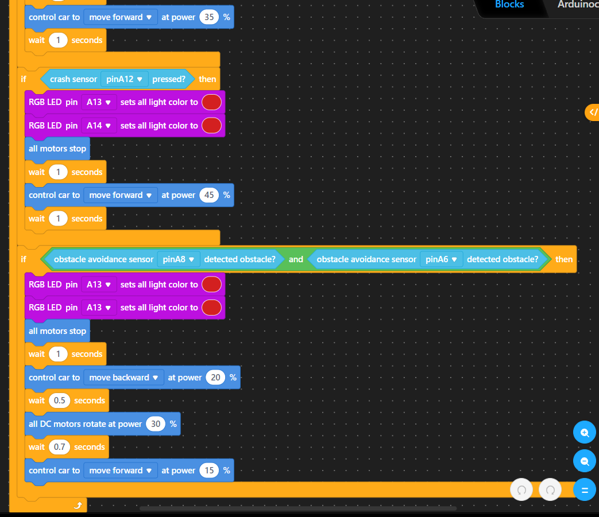

(All of this code can be found in our cheat sheet)  
  
4. Between each part, the students will test run the bot using obstacles around them, or the created obstacle course